The overarching human predicament; the overarching truth.
The following graphic (via Nicholas Georgescu-Roegen) is the simplest big-picture expression of what REALLY happens; the big-picture truth about human existentiality.
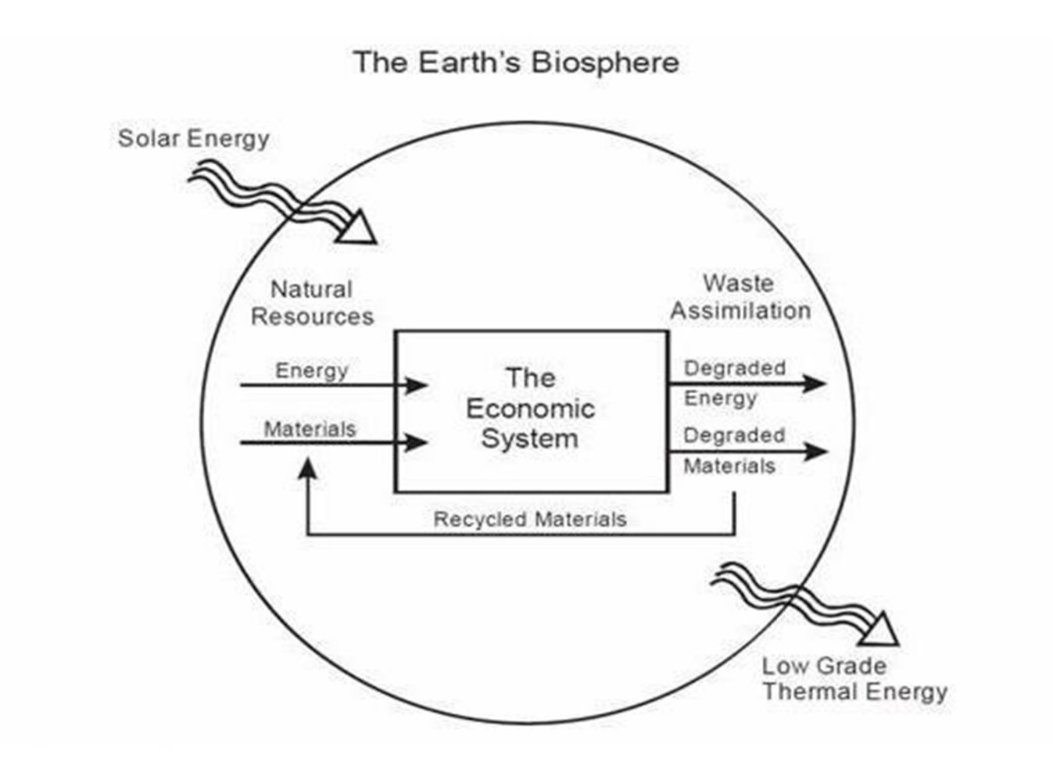
Flows, entropy, linear/circular
The only input is solar energy; the only output is low-grade heat (too low to be used to produce work).
The flows across that diagram, are inexorably left-to-right. The 2nd Law of Thermodynamics applies, and every NZ reporter/journalist should have an understanding of it - and therefore of entropy, and of dissipation. (Note; learning Maori does not equate to having an understanding of the 2nd Law; this hierarchy of importance suggests that interdisciplinary genuflection is a flaw in tertiary education… and consequentially in the media which fails to challenge it).
That inexorable left-to-right flow, is why a hot cup of coffee always cools and never re-heats; why stuff rusts/corrodes/breaks down, never heals/fixes itself.
Materials (resources) can be partially recycled, but always remember; recycling requires energy. So much so, that we mostly choose not to recycle.
Limits to Growth
Unarguably, there are limits to the exponential growth possibilities based upon extraction from a finite planet (from a Bounded System, in Systems-speak). Unarguably, exponential growth is measured in ‘doubling-time’. Unarguably, the economics posit – that at a certain price point a substitute will always be found – is bollocks, given ‘finite’ and ‘doubling’. That concept should demand no great intellectual strain; why then are plans for endless growth left unchallenged when stated? The standard economics posit – that economic growth is both desirable and possible indefinitely on a finite planet – is an overarching fallacy. Time we addressed that fact.
The Limits to Growth have been well traversed; Club of Rome/World3/MIT 1970-72, 10-year updates, Turner/2014, Herrington/Harvard/2019, Murphy, Rees, Hall, Watkin, Diamond, Wright, Bartlett, Morgan – but, increasingly since the initial flurry, not the MSM.
World3 – the graph
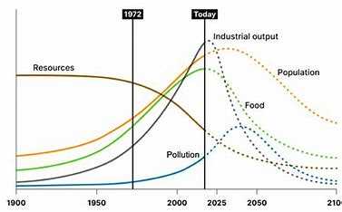
There are many versions/formats, but the (peer-reviewed) gist is basically the same. Note the inflection-points happening ABOUT NOW. Many variations have been run, by the original authors and since, but only drastic de-consumption alters the outcome, and drastic de-consumption would appear to be incompatible with economic growth. The programme was run with ‘double resources’ - as if we had another planet - and it merely extended the curve by a few decades (Herrington posits that ‘double resources’ is the best fit to our current consumption trajectory – but note that there is indeed only one planet… meaning the drop-off is likely to be steeper – a Seneca Cliff/Event).
Money – a false measure
Money is an artificial proxy, keystroked into existence as fiat-levered debt. Debt expects to be repaid, usually plus interest, in the future.
That artificial proxy is an expectation that it can be taken to the left-hand-side of the box (in the first diagram) and cashed-in for energy and materials (processed resources; stuff) from those two incoming arrows. Regardless of choice of token/storage format – Kiwisaver/shares, physical equity, cash, bonds, savings, crypto - the assumption is that both inflows will be available in the future, not just at recent rates; but at exponentially greater ones.
If there is no flow from those incoming arrows (empty shelves) money ceases to be a ‘store of value’. If there is curtailed flow (reduced stock for sale) money becomes reduced in value. Money is at best a collection of betting-chips on the future; money is therefore NOT a store of ‘value’. This has serious implications for ‘investments’ of all kinds, and challenges phrases like: ‘making money’; ‘putting money to work’; ‘investing’; ‘return’.
There is a powerful incentive for those competing within the box, to avoid the ‘costs’ of the two (degraded energy, degraded materials) exiting arrows. Both, however, have the physical ability to scale to life-threatening levels; pollution (climate-alteration being just one result of pollution); biodiversity-loss/habitat alteration/another; ultimate resource scarcity another; entropy (think: decay) yet another.
The false graphic used by economists:
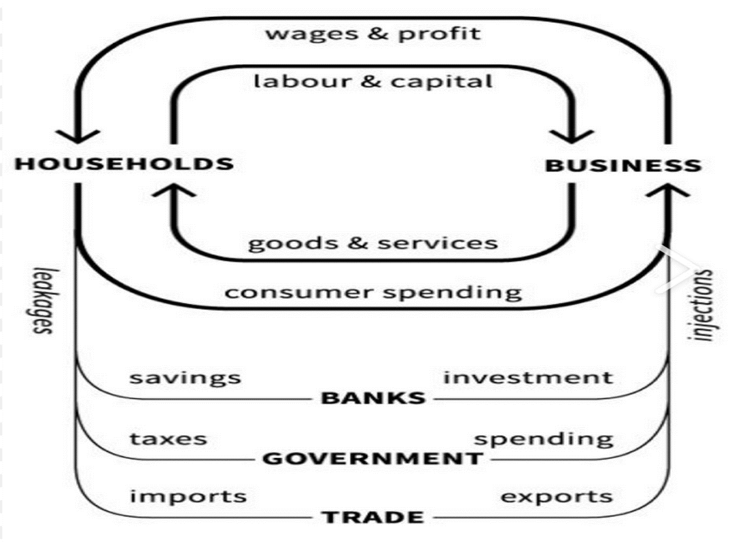
Note the lack of input/output arrows, as per the first graphic. If pushed, economists will refer to them as ‘externalities’. Problems arise, however, when existential threats arise from these ‘externalities’, threats which cannot be accounted-away using keystroke-issued proxy, nor by consulting externality-ignoring counts like GDP.
That graphic is, to put it bluntly, a falsehood. Yet the media takes it for granted, unquestioned (for many years the ODT has had a column headed ‘Business and money’ – between the following brackets I list all their reflections over those years, as to whether money is/was a valid measure ( ). Assumptions like that have no part in good journalism.
Productivity – and energy efficiencies.
The economists’ bible was written by Adam Smith prior to fossilised sunlight displacing human labour. Fossil energy so outranks human labour (try pushing your car home, digging a ditch by hand, or arm-flapping your way to Europe) that labour is mere noise in terms of ‘work done’.
Energy-use is limited by the Laws of Thermodynamics; productivity therefore has real thermodynamic limits; Carnot applies, as does the law of diminishing returns. This is why ‘productivity’ has flattened-off in recent decades; the same reason IC cars require radiators. No NZ journalist/reporter, academic or politician, has yet, apparently, made that connection.
Real wealth
Wealth, in the first diagram, is being able to go to the left-hand-side of the box, and exchange proxy for a portion of the energy/material (resource) flows. During the initial abundance phase (all these stocks are either finite or rate-limited; abundance is therefore initial but not permanent) it was valid to argue as to who had how much proxy. The Left was for more equality; the Right for less equality.
But poverty is really a lack of access to those two incoming flows. Thus ‘child poverty’ is really: ‘Child lack of access to energy/resource flows’ (adjustable in equality terms by legislating an equal share – but in overall terms, decreasable only by reducing population, access to those flows being ‘per head’).
Beyond the inflection-point though – known to many of us as ‘The Limits to Growth’ – there will be increasing amounts of proxy chasing decreasing stocks of energy/resources. The graphs cross; increasing amounts of debt become un-assuage-able at currently-understood ‘values’.
From that point on, ‘budgeting’ in $$$$$, becomes increasingly invalid. Physically earmarking forward energy and resources from the remaining stocks – including enough to cover maintenance (re-sealing of roads, etc.) – becomes the only game in town. (Expect, then, increasing stridence and war(s) over ‘what’s left’.)
This is exacerbated by entropy/dissipation, for instance houses are really decaying collections of resources, and representations of some already-expended high-grade energy. They are really physically-decaying (physically depreciating) structures, but are being ‘valued’ upward in keystroked tokens; a Ponzi with inflationary implications. What is money ‘worth’, then, if the future increasingly fails to deliver the energy and materials required to produce those goods and service? Inflation would be permanent and increasing, regardless of interest-rates, a concepy seemingly beyond the grasp of economics-taught/economics-believing scribes.
Energy
The first graphic tells us that energy (geothermal and nuclear the qualified exceptions) originates from the sun. Oil, coal and gas are millennia-stored solar; firewood is decades-stored solar, food is seasons-stored solar. The point here is simple; we will end up running on real-time solar input, once we have burned our way through the stored stocks – which we are currently ADDING to real-time solar. This posit is irrefutable and (given exponential growth and doubling-times) the reduction/depletion implications are near-term and massive.
Real-time solar energy lands at 1kw/square metre, and the best conversion-rates (photosynthesis, PV) average less than 30% capture of that (see: Sustainable Energy without the hot air).
The concept of EROEI (Energy Return on Energy Invested).
A wolf chases a rabbit. If the eating of it returns the wolf less energy than the chase expended, the wolf becomes thinner. Repeated; the wolf dies. So too with all life (food being energy; we are currently eating our way through multiple fossil-energy calories per calorie of produced food; a temporary arrangement) and with all technological constructs.
We have burned the best-EROEI fossil energy; it’s gone. We are retreating down the surplus ratios, and close to, if not beyond, the level below which our societal constructs cannot be maintained.
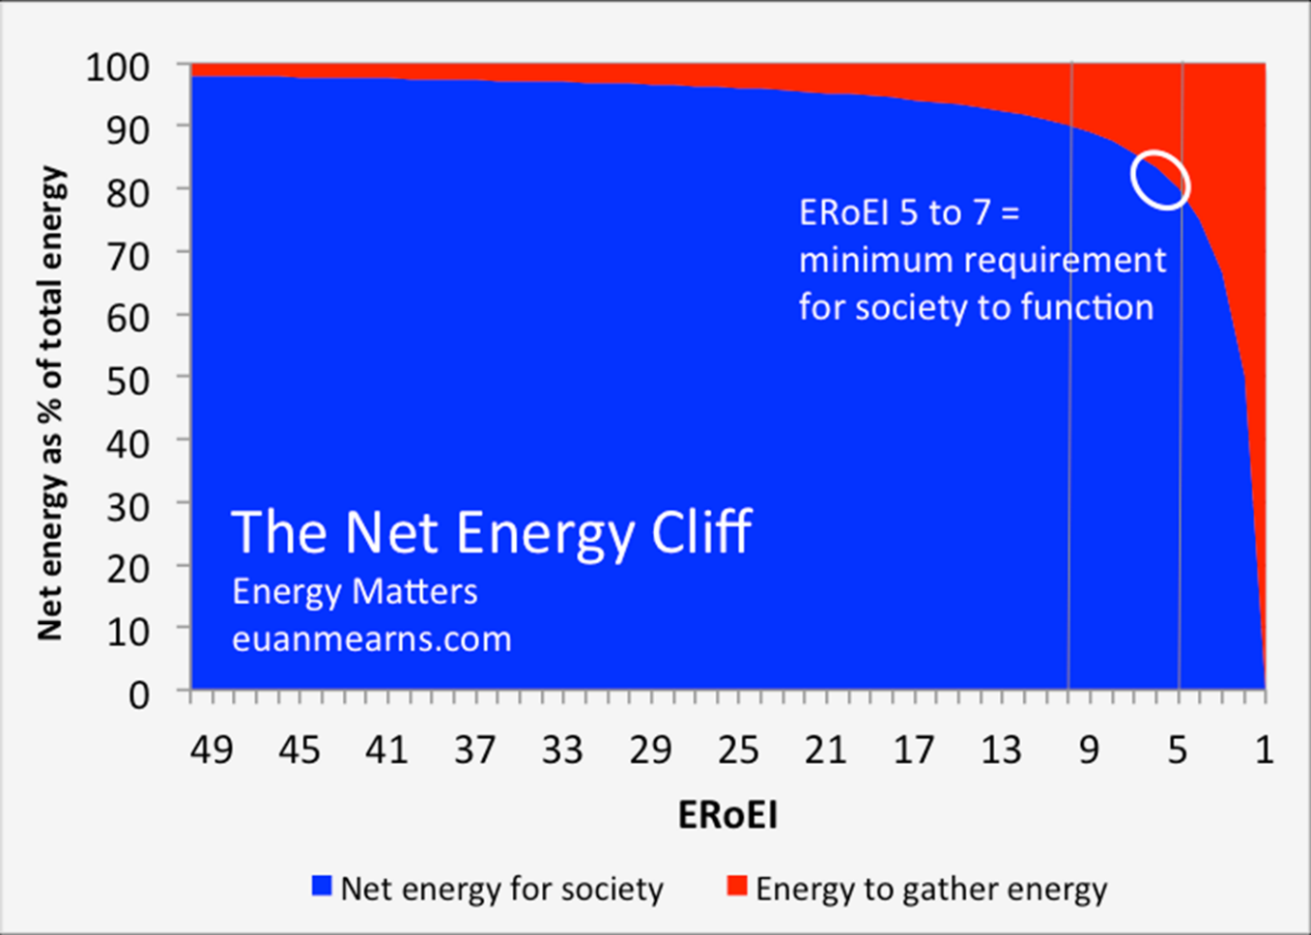
Note – hydrogen is a negative EROEI (a net energy loss) and is a vector, not a source.
Overshoot, Planetary Boundaries, Climate-myopia.
In a recent Listener article, Danyl McLachlan stated incorrectly: ‘…the degrowth movement, which believes climate change can be solved simply by convening a world government that dismantles the industrial economy’.
In fact, the de-growth movement is concerned with human overshoot and Planetary Boundaries – of which climate change is merely one aspect.
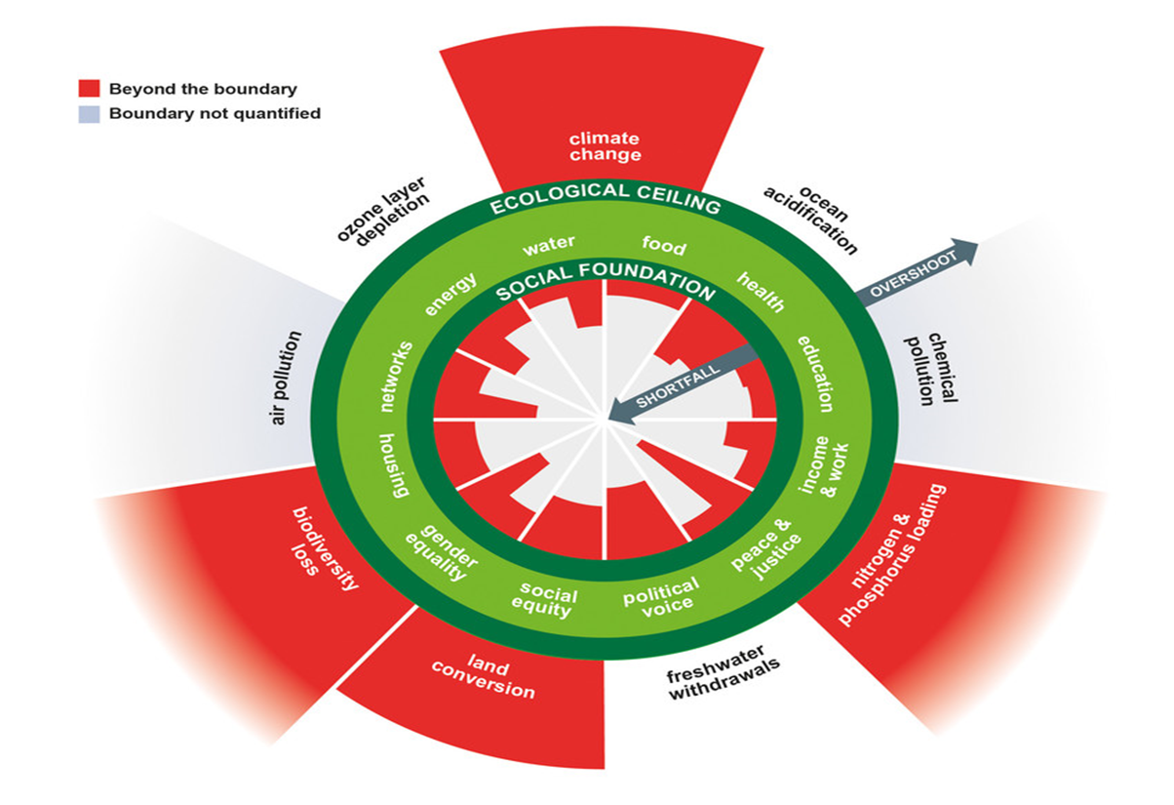

(graphic: Raworth/Doughnut Economics, via Rockstrom et al)
We are a species in gross overshoot; done by levering stored solar energy and by depleting resource stocks (and degrading them, because we always take the best, first). Estimates of long-term planetary carrying-capacity without depleting those stocks (or post-depletion) depend on desired per-head consumption-rates, and range from 2 billion (at good-peasant level) down to 1 billion or even below (at our current consumption-level).
Degrowth WILL happen; the degrowth movement merely suggests that voluntary is better than involuntary… Assumptions; the parents of all flawed thought-sequences…
Limits to Growth
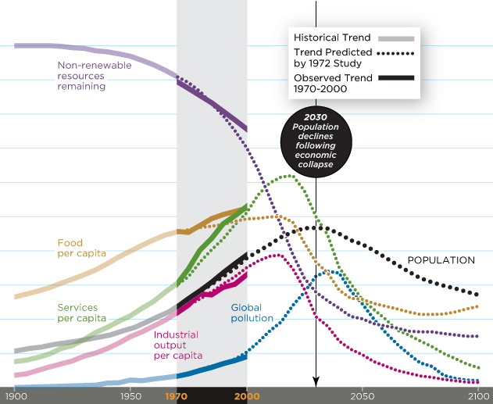
The above graphic is the BAU run of World3, continually reviewed since 1972 (most recently Gaya Herrington/Harvard). Note the non-renewable resource trajectory, and the timing of the inflections.
The real issue
The first fact is that fossil energy is finite. We are about half-way through the stock; exponential growth says the last half gets used in one doubling-time (@3%; 24 years; a moot point, of course; if growth is dependent on a dwindling energy-supply…).
The second is that we will end up on renewable (better described as ‘rebuildable’; dams, windmills, PV) energy. Given that it needs the existing to build the new, the sooner we do whatever we decide to do, the better.
The third, however, is that NO solar-sourced energy format (PV, wind, hydro) has yet built – or proven it can build - replacement of itself. It appears likely therefore, that the fleet of ‘renewables’ existing through the demise of fossil energy, will be the last. Thus the Green New Deal folk – the drive an EV, recycle, party-on types – are as incorrect as the fossil-touting dinosaurs.
The question, then, is: What level of social activity (movement/work, therefore production/trading, therefore infrastructure) will we be able to maintain? And how many people can NZ support using real-time solar energy, ex resource draw-down? This, of course, had DIRECT implications for the DCC.
Invalidating ‘cheap’.
The oft-repeated claim that PV is ‘cheaper’, merely reinforces the fact that money is a false measure. PV is further down the EROEI ratio-list than fossil energy, therefore it can support less work (surplus work, after building/delivering/installing itself) than fossil energy, per input effort. We should be measuring to include depletion of stocks (both energy and resource) and to include work do-able (perhaps accounting the Joule as collateral).
It can be argued that the concurrent malaise hitting local authorities, health, tertiary education (plus the currently-held debt overhang) is indicative of reducing EROEI (a curtailment of the top left in-arrow, first diagram) and of resource-reduction (a curtailment of the lower in-arrow; more-scattered minerals for instance, which require more fossil energy to gather…). The follow-on is that these pressures will not ‘go away’; they will increase.
Identifying Spin
Bernays (Freud’s nephew) started what has developed into propaganda, marketing and spin. Those have become ever-more sophisticated, but a truism still holds; if someone is peddling something untrue masquerading as true, there will be an identifiable divergence-point. The trick is to peruse such emanations critically, looking for those divergences. It may be something like purposely overlooking the offshoring of an activity; it is often the switching of accounting (Air NZ did this recently; CO2 suddenly became dollars and jobs…). Lomborg’s The Skeptical Environmentalist, McAfee’s More from Less, and closer to home, Hartley’s Conservation Strategies for New Zealand – all reward such critical appraisal. Often there is traceable association with vested-interest/powerbroker backing…
Eventually
Physically, we will triage our way down to a maintainable level, perhaps with urgency (war, pandemic, financial collapse). Internet-reliance may be seen, in hindsight, as a less-than-smart move. Maintaining societal cohesion may be beyond us at national level; local cohesion may be all we can manage (see: Tainter, Collapse of Complex Societies, 1988).
Energy-wise, fossil energy will become unavailable. PV will not manufacture PV, but pre-obtained PV will be usable for the remainder of its life-time. PV is therefore a way of storing fossil energy to dissipate over a longer-but-not-indefinite time. That is a valid goal; building extra roads (out of fossil feedstock – bitumen) clearly is not.
Food-production ex fossil energy will be our biggest headache, but because of our energy-blindness (per: Nate Hagens: Great Simplification.com) we have yet to show awareness of this. It currently requires 10-30 calories of fossil energy (depending on accounting methodology) to deliver 1 calories of food; this is a temporary arrangement. In comparison, climate implications for food production are secondary.
Local Government’s dilemma
Local governance and its physical infrastructure, was constructed during the – temporary – growth period. Along with other arenas – education, health, services – it is increasingly struggling to maintain, and will soon probably struggle even to exist. The halcyon days – traceable to times of unlimited surplus energy – are largely gone.
Unfortunately, our unfolding predicament needs detailed investigation, now more than ever before. For a growing cohort, the old narrative no longer fits the facts (and those still lauding the old, can be heard echoing up their own rabbit-hole, dismissing others busy digging their own). Cause is conflated with symptom, for instance Trump, Putin, Brexit and Farage are symptoms; lack of surplus energy, coupled with entropy, is the underlying cause.
From here?

More than ever, we need to be thinking clearly. More than ever, we need the facts, clean and clear, unsullied by reference to an artificially-keystroked proxy. The very existence of our offspring, and theirs, not to mention the other life-forms with which we share this planet, will depend on how smart we get, how fast.
Murray Grimwood
Sustainability researcher

The following links repay lengthy perusal:
https://online.ucpress.edu/gp/article/5/1/122343/203074/Who-Will-Pay-Back-the-Earth-Revaluing-Net-Energy
http://www.withouthotair.com/
https://surplusenergyeconomics.wordpress.com/2024/09/17/289-project-2050-part-one/
https://www.thegreatsimplification.com/
https://dothemath.ucsd.edu/2015/04/programmed-to-ignore/
https://www.resilience.org/
https://www.planetcritical.com/

(Overleaf I attach my submission to the DCC, re your LTP in 2015. I add, within the following brackets, the research you have made into that submission, and the actions you have taken as a result. (………………………………………………………………)
I call that inadequate. In fact, on behalf of my grandchildren, make that charge: criminally negligent.

Submission to LTP, 2015
The – Your - Problem is that Money is underwritten by Energy.
All of us have lived through a period where money bought our needed/desired stuff. We lost sight of where the stuff came from, what it was made of and what delivered it to us. That is about to change. Given that leadership must be about the future (not the past) you should examine what is ahead. The ‘wish to avoid’ is entirely understandable, but don’t ever confuse avoidance with leadership.
Global finance requires exponential growth, and is therefore a Ponzi-scheme, given that planetary resources - including its ability to tolerate alterations - are limited. Global finance will therefore – in the near term – either fail, or we’ll see Weimar-style inflation. Either way, access to energy (the linchpin resource) or materials will be increasingly compromised. Your aim – on behalf of those you represent – should be ‘maximum resilience’.
‘Growth’ – be it of ‘money’ or population or infrastructure, is the opposite of ‘Sustainable’, and is therefore an invalid societal goal; no matter how desirable.
The Big Picture: Framing and Timescale.

This graph was run with ‘Double Resources’ (as if we had two planets); it bought a 30-year delay. We do not have a second planet.
The bigger picture.
Nothing can be addressed at community-leadership level, without understanding (and simultaneously addressing) money, growth, depletion/degradation, genuine sustainability, and ENERGY. Nothing – repeat nothing – happens without energy. The same cannot be said of money, or indeed of anything else.
Money
Money is merely a proxy. I can write ‘one trillion dollars’ on a data stick and chuck it into the fire – I’ve lost a few cents worth of plastic. Our collective mistake was to mentally transfer the ‘value’ of what we expect to ‘buy’, to the proxy itself. That works until the supermarket shelves are empty, and then it doesn’t. Our current money system fails before that point; because it includes future purchase-expectations – think mortgages - too. (Think of it as wanting to buy 3 years supplies, at the very moment those shelves start to become empty).
Those shelves are stocked – with no exceptions - by work having been done. That – with no exceptions - requires the use of energy (the only variable being efficiencies). Our so-called economic expansion over the last 200 years was largely underwritten by nothing more than the increased extraction/use of Fossil Fuels. The game has been obfuscated to an almost total degree, by assertions that other drivers (population, technology, capital, the human brain, democracy, free markets, to name but a few) were responsible.
The issued proxy (out of nothing, money is spun into existence as debt which banks immediately charge you to ‘borrow’, a process known as ‘fiat’ finance) had to fit a growth paradigm. There was no chance, starting from scratch, that a trading system could be designed to do anything else. There was equally-obviously no chance that such a growth-based financial system could survive a permanent reduction of its energy underwrite.
Three outcomes, in varying degree, can be expected in an emptying-shelf/ increasing-customers situation: a bidding-war for remaining essentials (inflation-inducing), a reduction in the value of everything discretionary (deflation-inducing), and a reduction in the underwriting and expectation of future proxies (interest, profit, returns). Combined, the ‘value’ of existing assets can be expected to fall, bubble (for that is what the fiat-issued upstroke is/was) style. Income-compromised folk will be trading-down, reducing the ‘market price’ of those assets (Inflated prices of existing houses, for instance, may fall to their1970 levels), while those who wish to buy, also income-compromised, can only offer increasingly less. Future bets – loans, insurance – face a negative-average future, which means that increasingly they either won’t be made, or they will default. The currently-held combined ‘wealth’ expectation is some orders of magnitude more than the physical planet can underwrite (energy being the essential factor in all other extraction).
The players in our current game can fool themselves into thinking they can buy ever-more off the shelves. Inflated prices of existing houses are a classic example; folk borrow against the increased ‘value’ and while in this ‘debt’, pay rates to Councils. Lawyers charge for the transactions, pay their rates from this, and head for those shelves with the rest. What, exactly, changed? Same house. Same planet. What is it, exactly, that the house-owner, lawyer and Council are spending on that real work, done by using real energy? There is no guaranteed correlation – it worked until it won’t. This mental disconnect is endemic throughout society; which will require a massive – and rapid – re-evaluation – something which could/should be facilitated by good civic leadership.
Growth
Growth is exponential, and is expressed in terms of ‘doubling time. 3% growth, however innocuous it sounds, doubles in 24 years, and expects 8x whatever the activity was, at the end of a century. 21 doublings take you to the ‘million times whatever it was’ mark- Tui-ad territory.
The graph of ‘doubling-time’* starts from the left, climbs slowly for a while, curves upward then goes vertical. When it is in the vertical phase, you haven’t much time before it stops – regardless of the item being tracked.
With a finite resource – and Fossil Fuels are a finite resource – you can know with certainty what happens in a growth-of-use scenario, even if you are unsure how much your total is. Counting back from ‘all-gone’, your last doubling was from ½-way. The one before that was from ¼ to ½, the one before that from 1/8 to ¼. Three doublings, from 1/8 to ‘all gone’, regardless of how many doublings it took you to get to ‘1/8 gone’. Most folk don’t see it coming, no folk react fast enough. We are at-or-about ½ way, now.
Energy
A significant percentage of one species may have believed, briefly, that an artificially-contrived proxy was the driver; they were wrong. We currently use energy, as if we had 300 slaves apiece, working 24/7. Related to our 8-hour day, that’s 1000 times what we can do ourselves. It is important to bear this in mind, when discussing, say, demographics (we’d need 1000 care-workers each in our dotage), voluntary labour, food security, or infrastructure maintenance. The source is fossil – and therefore finite – fuels. First coal, then oil. We have used them to artificially push agriculture, global population, indeed everything, to unsustainable levels. No proven, viable, scalable alternative exists, and it is invalid leadership to assume that any will; default planning is the only failsafe option.
Sustainability
The Brundtland definition is a good start, but it falls short, for the same reason our RMA currently falls short via this insertion: Part2, Purpose (2): ‘which enables…..communities to provide for their…..economic……wellbeing’). While ‘economic wellbeing’ includes growth of consumption, the phrase has no place in a description of sustainability.
We fall several orders of magnitude short of the Brundtland yardstick, thanks to our rate of consumption of a finite, once-off source of energy. Given that the alternative is unsustainability – presumably an invalid goal for a rational society – Council need to look several generations ahead. Perhaps a ‘100-year plan’?
Those who benefit from Business as Usual (and this includes the commercial media) will continue to push for the unsustainable. Spin, surveys of optimism, rear-view projections, screaming editorials and quashing of undesirable debate/opinion, can be expected. Good community leadership should either anticipate the need to circumvent/ challenge these institutions/people, and/or to facilitate their education. We can expect a period of leadership dyslexia – going off to China pimping for ‘investment’, for example, or advocating hotels (air travel will fade, cruise ships won’t but don’t require accommodation). In the transition phase efforts must be made to move on from that cognitively-dissonant approach as quickly as possible.
EROEI
Fossil energy – a one-off boost of stored solar energy, taking millions of years to form yet being consumed in less than 300 – is peaking. Exacerbating the problem is the fact that we cherry-pick the best of anything, first. With energy, that’s the best dam-sites, best/closest oil, and most concentrated coal. This sequence guarantees that we must assume a quality-descent, and that the last half will be the worst-quality half. The concept is known as EROEI – Energy Return on Energy Invested. If a wolf expends more energy chasing a rabbit than the eating of it returns, the wolf dies. There can be a thousand rabbits; the wolf dies. The wolf can be a billionaire; the wolf dies. His energy return on energy invested was negative. Period. We cherry-picked the Beverly-Hillbillies gushers first, and are down to fracking, deep-water, kerogen etc – sure sign we are heading for the bottom of the barrel. Starting with an EROEI of perhaps 100:1, we are down to 13:1 or so, and estimates are that Business as Usual can’t be maintained below 8:1 (regardless of the number of rabbits, read: barrels of oil). The effort to obtain the energy is more and more triaged from the work we used to do with it. Our system appears to be unable to ‘fund’ more ‘expensive’ energy; it has withdrawn from coal, then oil. We are now coasting along on what has been found/tapped already, without the forward investment. That situation is unsustainable, and will therefore cease.
Alternative Energy?
Are there alternatives? Yes, but not of good enough EROEI, not compact enough, nor in enough supply. Biofuels don’t scale, bad EROEI. Hydrogen is a vector not a source, bad EROEI. Nuclear is finite, too slow a lead-time, and only provides electricity.
Logically we will end up with renewables, by default. They do electricity, but not feedstock. None pack the punch-per-weight-of-carried-tankful that oil does, thus curtailing heavy haulage, tractors and diggers. Renewables don’t scale (restrictions include conductor-availability etc) enough to underwrite global BAU, although it may be viable to morph NZ as a (severely triaged) stand-alone entity.
Technology?
Can save us? No. Technology can only help us use energy more efficiently – it can’t invent the stuff. That development follows the inevitable path of ‘diminishing returns’ and runs afoul of the ‘Jevons Paradox’.
Efficiencies, then?
Will efficiencies outpace depletion? No. It is important to remember that we cherry-pick the low-hanging fruit here too. In any given activity, you can only be a theoretical 100% efficient, starting from wherever you are. (For instance, diesel engines start at 30-40% efficient, and will never top, say, 60%). A cherry-picking regime always follow a diminishing-returns path, and effectively ceases at some practical point; this process can slow, but never displace, accelerating depletion (for instance, Moore’s Law runs into molecular cross-talk and heat-dissipation limits at some inevitable stage). Jevons Paradox applies here too. Regardless of that, efficiencies are a valid part of the required mix. I suggest the Council look seriously at subsidising/funding the documenting of something like the Homestar Rating** for existing dwellings, impose a mandatory energy-efficiency threshold (R value per floor area?) for new buildings, and look at partnerships with Education suppliers to embed this thinking in the community.
Putting it all together
Council – as do everyone else – has a problem. It expects to continue doing work, using energy. It expects to pay for that work, using the result of other people – ratepayers – doing work /using energy. In a dwindling-supply/greater-demand/lowering quality scenario, the costs ramp for the same reason that incomes fall (they are flip sides of the same coin), and the divergence has to accelerate year-on-year. Globally, locally and individually, we have never had more infrastructure, all ageing. Increasingly, triage will be the order of the day. Simultaneously, the global fiscal system will be compromised, and may either crash or be manipulated (jacked-up interest rates causing defaults/fire-sales to those still in the game, for instance) to local disadvantage.
Energy-resilience, then, should include aiming for financial invulnerability, resource/infrastructure invulnerability, developing a researched triage-list, and a Civil-Defence-style plan for energy-descent. The concurrent onset of financial collapse (narrowly/temporarily staved-off in ’08) and/or direct energy scarcity, may be quite rapid when it becomes generally-realised that the status-quo is unsustainable.
Summing-up.
Energy underwrites money. No saleable item or activity can be proffered without the doing of work, which requires the using of energy. We have been used to assuming that ‘Capital’ was the driver, whereas it was only a facilitator. Energy will become scarcer physically, and more contested-for as well. It can be expected to become increasingly ‘expensive’; except that – because it also ultimately underwrites the incomes used to pay for it – the ‘payment’ system can be expected to fail at some ‘underwrite-depletion’ threshold.
Energy resilience, therefore, involves more than just making existing infrastructure ‘more efficient’. The increasing scarcity of the resource which makes bitumen, fertiliser and plastics, which carts concrete and tills land, harvests, transports, and underwrites nearly all income-generation, will compromise all those activities, simultaneously. The nearest precedent for what is needed at civic-leadership level is probably the concept of a ‘wartime footing’. This one, though, will be permanent. The likes of Roading, and Water and Waste, need to have an O&M plan taking this scarcity-vs-aging into account.
The chances are that citizens will be in turn, puzzled, shell-shocked, angry, and desperate. Strong, credible leadership will be needed, always easier if you can demonstrate pre-understanding/planning. Time-frame? The attached Smithsonian article, suggest 16 years to fiscal collapse/population decline, and the Peak Oil (peak energy supply rate) plateau appears to be with us now. Debt uptake appears to have outpaced that anticipated, so expect a shorter timeframe. Collapse may be extremely rapid, given that only faith and belief keep finance going; Russia being the classic example. It would be imprudent to plan on operating in anything but an increasingly-constrained – and perhaps chaotic - world.
Precedents of societies being impacted (at varying speeds) by energy-constraints are documented, and reward research. Given that we can expect an increasing proportion of our citizenry to be dollar-poor, concurrent with an increase in ‘work-needed-for-which-there-is-no-funding’, investigating a mechanism to mesh the two (hours swapped for rates-rebates?) would be sensible. Ownership of actual energy-sources (Waipori dams, for instance) may be worth pursuing, and no matter how fast we address efficiencies; it will not be fast enough.
Comments on your ‘Wish List’.
In light of the above, and in light of having to take the precautionary approach to Climate Change, we can make some – albeit unpalatable – assumptions.
Infrastructure: Given what is ahead, you cannot spend enough on upgrading, future-proofing and triaging infrastructure. It will never be ‘cheaper’. It will never be ‘easier’. You are late already.
Central City This is a discretionary wish-topic which reminds me of the ‘80’s; western middle-class society avoiding the realities so as to pat itself on the back. Dump it; you have more important things on your plate.
Cycleways are a valid approach, but keep in mind the reasons for commuting; ‘work’ in the CBD won’t figure as highly in the future. Also bear in mind the reducing fossil-fuelled vehicle fleet (nil following fiscal collapse) which will leave vast acreages of – albeit decaying – tar seal. The other spin-offs of cycleways are getting folk used to the future, and inducing a higher level of health in the community – because (as you can see even now) health services will become increasingly compromised/unavailable.
Portobello Rd Will be underwater within the lifetime of citizens born now. You need a PlanB. Barging/ferries may be better than gouging another shelf, or how about re-routeing the high road.
South Dunedin will be underwater at some point, and will be abandoned prior to that; most probably in this century. You have to decide whether to defend the indefensible – the beach walls/dunes – and if so for how long. Same goes for any South Dunedin projects; underwater has two meanings.
The same goes for coastal defense generally; you won’t have the fossil-energy grunt to defend/replace, and there are too many kilometres to do it to. Someone should be mapping/planning the strategic withdrawal.
Literature? Great. We can’t get enough of it, and we’re proving we’re not informed enough yet, proving we’re not smart enough yet.
Gigatown was only a good idea if you were ignorant – and I chose the word with care – of what is ahead. Here’s the relevant link:
http://www.eenews.net/assets/2013/08/20/document_gw_02.pdf
It is the same misconception folk have with ‘money’ – that the ‘information economy’ or the ‘knowledge economy’ can lead to us being able to buy ever-more processed bits of a finite planet. No leader should be spouting such disconnected nonsense; that’s a coal-fired cloud.
Museum? Your call. It’s a discretionary activity, but a sense of community and belonging will be needed and therefore is worth nurturing.
Pools are a good idea – all of them. They are a weather-proof method of raising average health, with good social/fiscal spin-offs and no down-side.
Unfunded items: you’re going to be further and further behind the 8-ball as it is; drop ‘em.
Rates: Stop talking in percentages. For one, they’re exponential, for two, they bear no relativity to available resources including the ability of ratepayers to access those resources (to produce goods/services to ‘sell’ so they can ‘pay’ their rates). Increasingly, you won’t have enough ‘money’ just like every other edifice (think: Health). Explain what you’re about, explain why, and get on with it.
Debt There is no meaningful way the currently-held global debt can be repaid. So it won’t. Whether we attempt to inflate it away (per Steve Keen) or whether it implodes, is yet to be decided. If the system collapses, debt may vanish. If there is a half-way house, though, retrieval-rights may get sold, extravagant percentages charged, the inevitable foreclosures may lead to evictions and repossessions. At all levels. Lack of vulnerability is the goal.
Economic Strategy Given that energy underwrites money; you have put the cart before the horse in getting your Economic Development Strategy out first. Its goals, then – unsurprisingly – are invalid. In a collapsing or rampantly-inflating fiscal scenario, what meaning has ‘$10,000 richer’? It’s a nonsense. Actually, given where we are and what is happening (continuing Q.E, zero and sub-zero interest-rates, unrepayable global debt overhang, coal-‘price’ crashing, oil ‘price’ following, ‘investments’ - Waipori Fund, pension funds, ACC - doing the Ponzi thing through lack of alternatives, race-to-the-bottom currencies) it’s a bullshit goal, pure and simple.
Leadership History tells us that incumbent leadership has usually not made the transition to a major new paradigm; understandable given that their skill-sets will have been learned in the past. The process of replacing a now-inappropriate leadership can be messy, time-wasting and of uncertain outcome. It would be better – by far – if the existing leadership was prepared, informed, confident and capable as we negotiate the coming bottleneck.
A Delicate Dance The transition to ‘needs must’ from ‘obligations to Central Government, financial institutions, ratepayer expectations’ will be fraught. There will be resistance from the ‘old guard’ to applying any money/resources to the problem ahead of time. Reducing infrastructure vulnerability, though, should be able to be sold as ‘reducing future costs’.

Suggested Actions.

1. Council assemble a cross-discipline committee to assess the actions required to address Energy Descent. It should keep a watching brief on global fiscal uncertainty, global energy supply/demand rates, other resource depletion, and keep in mind that the graph at the beginning of this submission has had no valid rebuttal.

2. Future development/infrastructure should pass a clear “Is it Sustainable given Energy Descent?” threshold test. This will inevitably include triage, which in turn requires a long view.

3. Existing infrastructure should be assessed as to priority and maintainability, aging vs both fossil energy and fossil feedstock (they’re from the same source). Access which currently requires fossil energy – digging up pipes/conduits, for example – should be sorted to avoid same.

4. Council must acknowledge that Economic Development is an invalid stand-alone goal (for folk having cranial trouble with that, I recommend ‘The Lorax’, Seuss/Collins as an excellent primer). Money has never been directly linked to Natural Capital, and Energy is the ultimate underwriter; the bucks will stop there).

5. With the likelihood of a fiscal collapse and the certainty of diminishing incomes, Council should act on behalf of its incumbent ratepayers (they will be under increasing threat of being ownership-displaced). This may require different mechanisms for ratepayers to assuage their obligations, and an understanding that charges/remunerations may have to be increasingly lowered, even as costs increasingly increase.

6. Localisation and protectionism can be anticipated. Leadership will be needed to safeguard local interests, and – ideology aside – attempts to divest them of assets (impossible-to-repay debts are one method of disinvestment, happening now via inflated house-prices) or load them with obligations (like student loans) should be resisted. Challenged, even.

7. Citizen energy-resilience should be actively encouraged. An Energy-Rating assessment of houses (the Homestar Rating is a suggestion) embedded in property appraisals/reports, would give clear guidance as to ‘best next moves’. Rates-relief to encourage the making of valid efficiency improvements should be investigated. (Net reduction in outgoings, has the same effect as net increase income – a currently-stated Goal). Subdivision in shaded areas should be discouraged/outlawed, and shading of adjacent properties/roofs

8. The assessed timeframe has to be as long as possible, with an update mechanism. I suggest a two-tier approach; a 20-year and a 100-year plan, with yearly re-visits of the former, and say 5-year updates of the latter.

9. Energy security should be encouraged, at all levels. Solar water-heating is the logical starting-point, insulation a close second.

10. New builds / rebuilds should be encouraged – by rule if necessary – to take advantage of solar gain/orientation; particularly penalising South-facing aspects and glazing.
11. When this hits – and I’m predicting a global fiscal haemorrhage in less than 5 years, probably less than 2 – folk will be bewildered, stressed, angry, depressed. Simple guides (to: planting/composting/supporting/volunteering/contributing/recycling/reusing/avoiding debt) would be good to have ready.
12. Information: the mainstream media are doing a fantastic job of avoiding this issue; going to great lengths to prolong their – and therefore our – ignorance (Sadly, their early arrival could have helped Local Authorities and individuals avoid incurring debt – and therefore vulnerability – but that is past history). That doesn’t mean they’re bad people, they’ll just be scared, in denial, believers or cognitively-dissonant in average proportion. Underneath they are civic-minded and will be there somewhere about the ‘Churchill takes over from Chamberlain’ time. Clear information-dissemination will be important; Moses did it with 10 bullet-points on one A4.
13. Triage will be required; multidisciplinary triage up to and including ruthless. For example; it would take fossil fuels, and more than we can ever ‘afford’, to defend South Dunedin from the effects of burning them. Timing that abandonment – should a cohesive society still exist – will be an interesting exercise.
……………………………………………………………………………………………………………………………………………..
“but after forty years of public policy denial of the limits to growth conundrum by government, the media and other sources of power and public policy, the bottom up adaption strategy is the only one with any remaining utility”.
David Holmgren, 2012.

“ It would be a pity if that were to remain true”.
Murray Grimwood to DCC, 2013. (The date refers to when this was first submitted, to your ‘Energy Plan’. It has yet to see the light of day. Why?)

References/links:

*http://www.mnforsustain.org/bartlett_arithmetic_presentation_long.htm#III.%20%20The%20Power%20of%20Powers%20of%20Two
**http://homestar.org.nz/
http://www.unece.org/oes/nutshell/2004-2005/focus_sustainable_development.html
http://www.zerohedge.com/news/chris-martenson-trouble-money
http://www.donellameadows.org/wp-content/userfiles/Limits-to-Growth-digital-scan-version.pdf
http://www.smithsonianmag.com/science-nature/Looking-Back-on-the-Limits-of-Growth.html
http://www.peakoil.org.au/limits.htm
http://www.resilience.org/stories/2011-04-04/commentary-will-we-be-able-maintain-replace-our-energy-transportation-infrastruct
http://simplicityinstitute.org/wp-content/uploads/2011/04/RetrofittingTheSuburbsSimplicityInstitute1.pdf
http://www.springer.com/engineering/energy+technology/book/978-1-4419-9397-7
http://physics.ucsd.edu/do-the-math/2012/04/economist-meets-physicist/
http://peak-oil.org/peak-oil-reference/peak-oil-data/
http://ourworld.unu.edu/en/to-power-up-or-power-down-that-is-the-question/
http://www.albartlett.org/presentations/arithmetic_population_energy.html
http://www.ted.com/talks/jared_diamond_on_why_societies_collapse.html
http://ourenergyfutures.org/page-titre-The_Jevons_Paradox-cid-25.html
http://simplicityinstitute.org/publications
http://www.mnforsustain.org/bartlett_arithmetic_presentation_long.htm
http://www.dublincity.ie/WaterWasteEnvironment/Sustainability/Documents/SEAP-FINAL%20version%20for%20website.pdf
http://www.peakprosperity.com/blog/trouble-money/73469
https://www.populationmedia.org/2012/04/04/the-meaning-of-sustainability-by-professor-emeritus-albert-a-bartlett/
http://www.albartlett.org/articles/art_reflections_part_1.html
http://www.simondale.net/house/essay.htm
http://questioneverything.typepad.com/
http://www.resilience.org/stories/2015-04-09/changing-human-circumstances
http://cluborlov.blogspot.co.nz/2015/02/extinctextincterextinctest.html#more

