Ōtepoti Dunedin: the hub of Otago’s Trail Network

Dunedin Tracks and Trails Submission to the 9-year plan
Ōtepoti, Dunedin a major multi-day trails hub for the country, with options for all levels of riders, as a jumping off point or final destination following exploring Central Otago and the Waitaki basin.
It is Dunedin Tracks Network Trusts goal to make this dream a reality by supporting the community to link to the 3 great rides at our borders and create a connected network of trails in Dunedin.
We are well on the way.
We submit the following actions from the DCC to support the momentum to achieve these goals:
- A letter of support for the Dunedin Tracks Network Trust’s vision to support applications for funding.
- DCC fund an independent consultant to analyse the economic, health and well-being, and liveability benefits of investing in connecting to the great rides at our borders and connecting local trails. (e.g. the Otago Peninsula Loop). This will assist with future funding applications and applying for Central Government funding.
- We support the Tunnels Trail project and want it added back in the 9-year plan starting from year one. This project should be given high priority, delivering operational sections as soon as possible. The Tunnels trail is Dunedin’s internal active transport corridor between the city, the Southern Suburbs and the Taieri Plains as well as a critical link to the Otago Trails network.
- Fund Dunedin Tracks Network Trust $50,000 per year to continue to progress the Coastal Community Cycle Connection and the Taieri Trail. This funding will assist with planning, landowner permissions and easements, resource consents and technical assessments and hasten the completion of these trails.
Dunedin City Council’s co- investment in connecting local trails and to the great rides at our borders will mean Otago will be the first region in New Zealand with a completely off-road active transport and recreational network of trails – Cementing Dunedin and Otago as a premier walking /cycling destination in the World. Bringing active transport, health and wellbeing, economic growth, fun and adventures to the whole region and the communities they are connected to.
With the Te Aka Otakau shared path and many wonderful trails, short walks/rides Dunedin is already an attractive walking/cycling destination. Connecting to the great rides mean people will start or end their journeys by spending time exploring Dunedin.
Presently Dunedin is missing out on the multiple opportunities and benefits across our communities and the environment and millions of low carbon, regenerative tourism dollars every year we are not connected to the great rides.
Queenstown, Wanaka, Central Otago, Southern Lakes and the Waitaki are testaments to the benefits of investing in trails not only economically but by also creating attractive places to live.

The Opportunity:
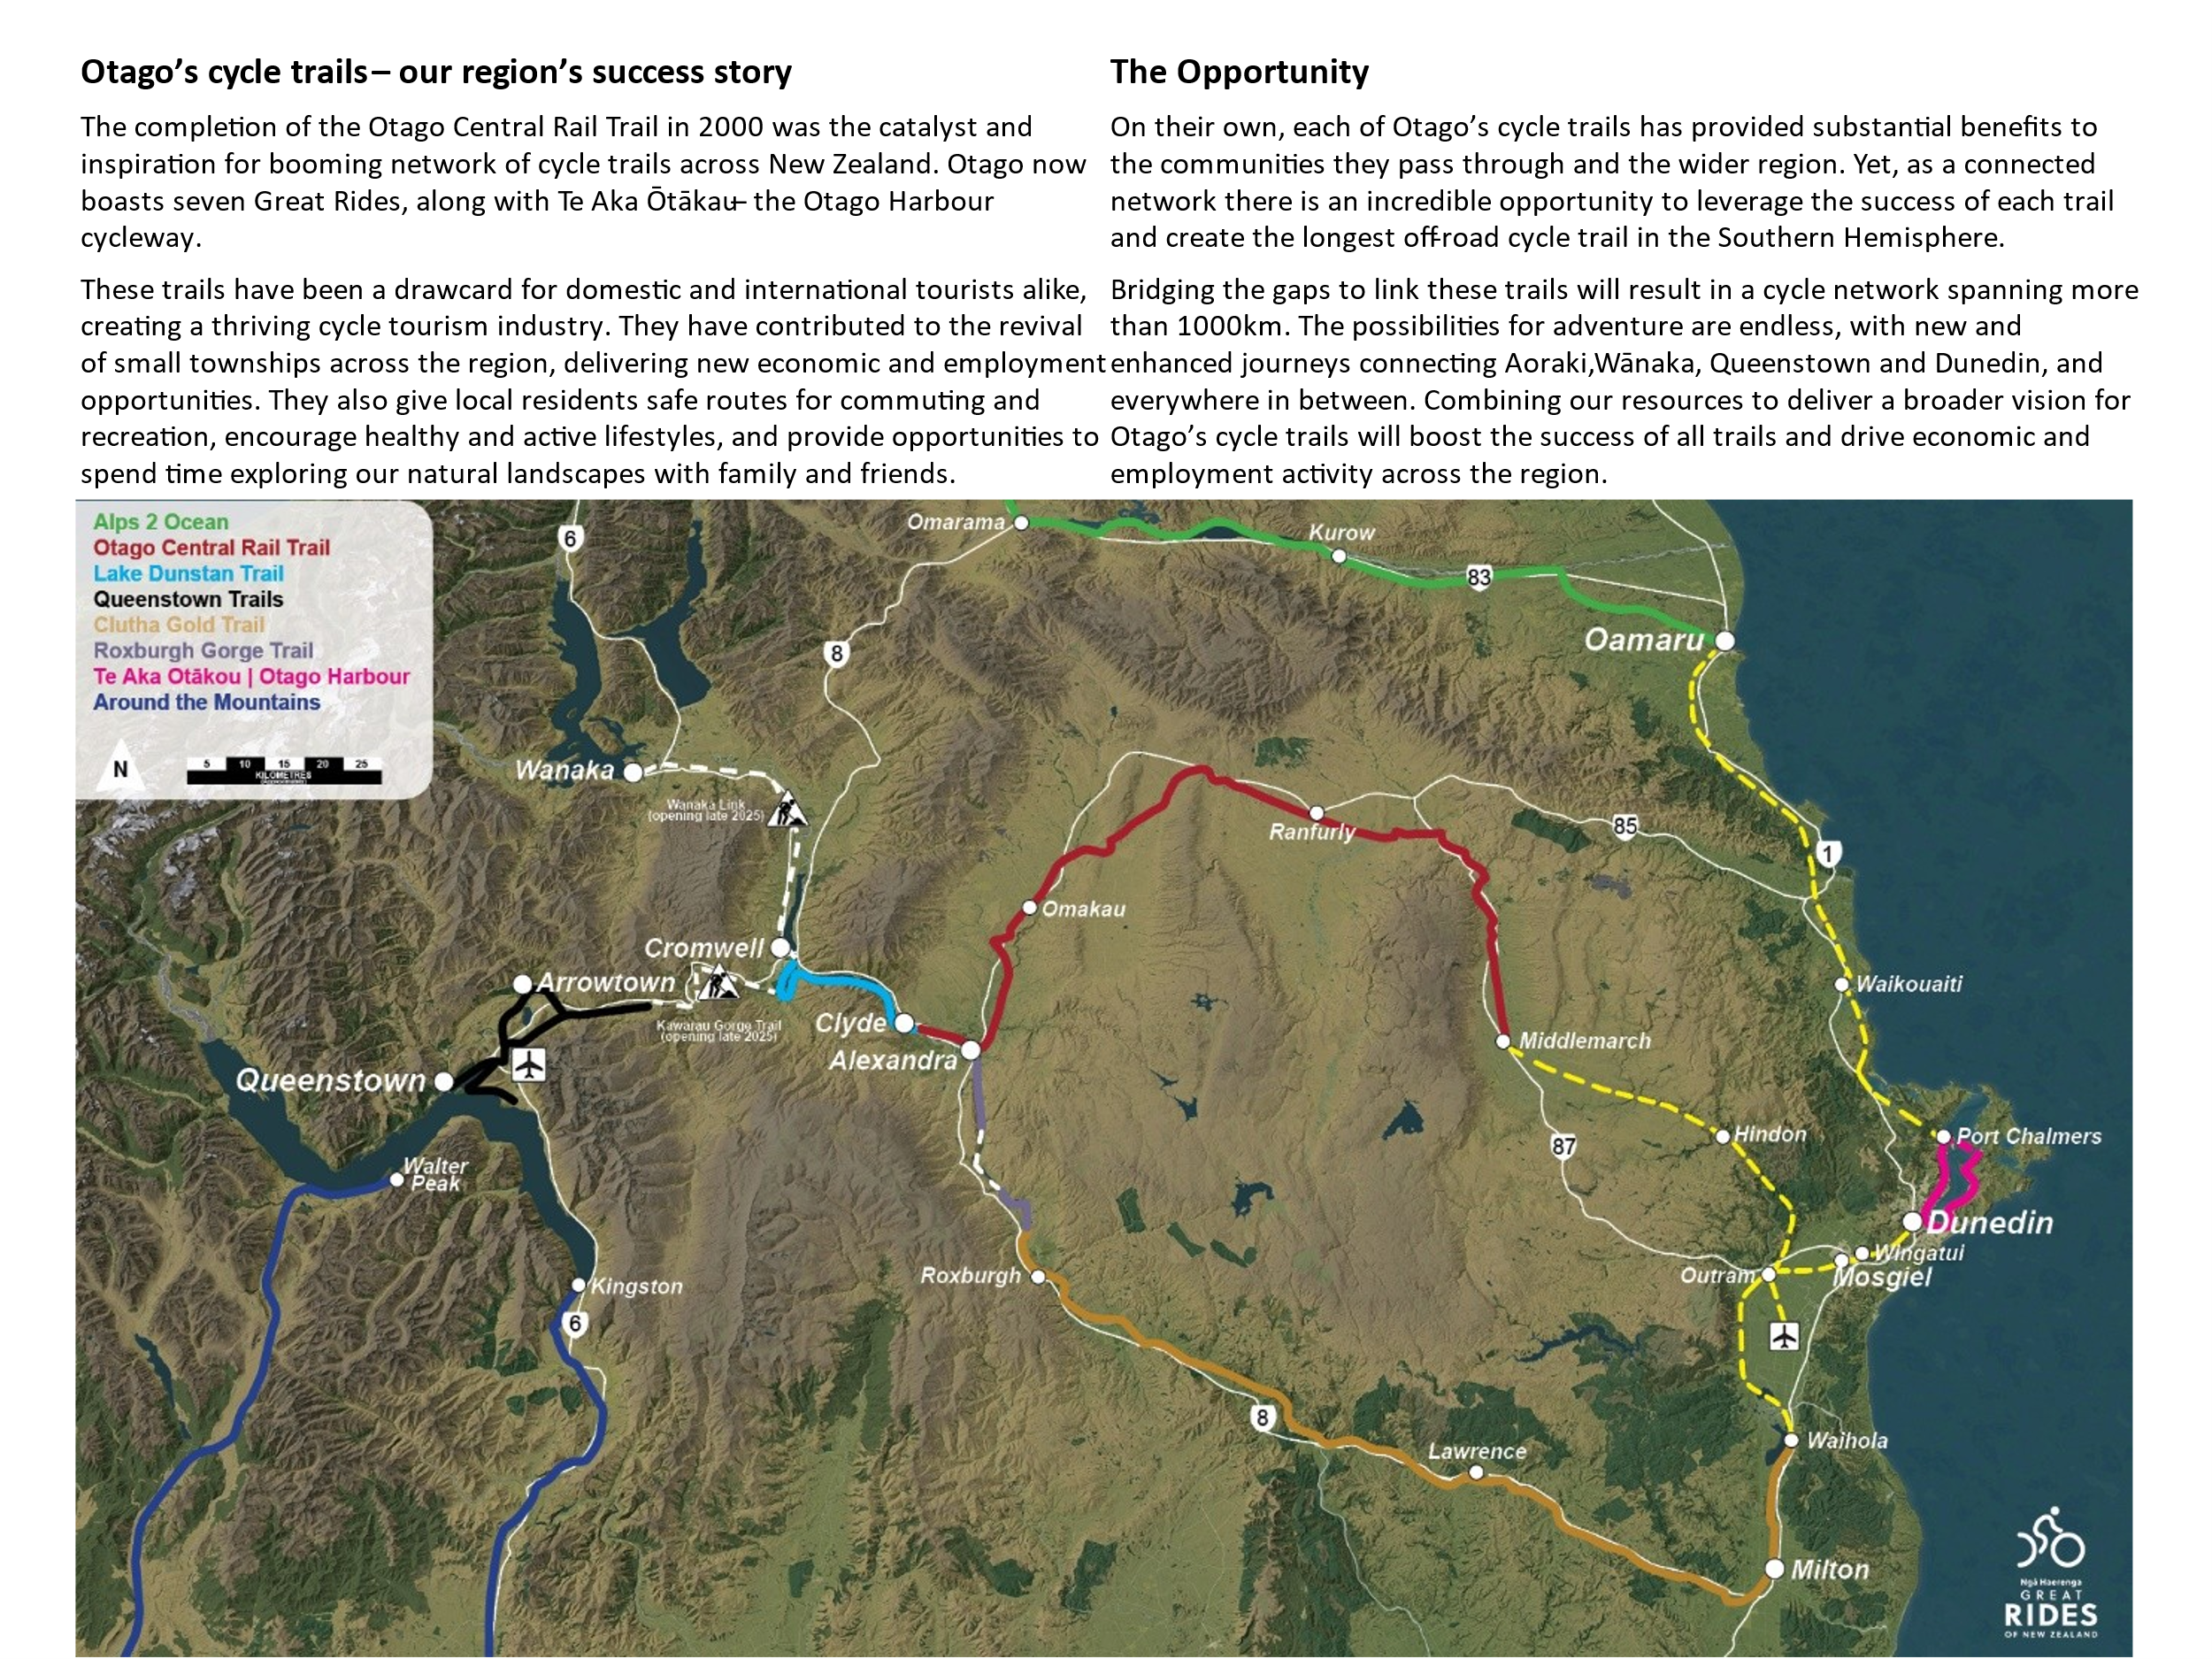
With the Kawerau and Roxburgh Gorge trails complete in the next 2/3 years there will be continuous trails from Queenstown to Waihola and to Middlemarch.
The Proof
Southern lakes/Central Otago
Top 10 in the world lonely planet
Top 10 in the world bookabach
6 % population growth
Activities people enjoy while in New Zealand
- 89% of locals, domestic and international visitors enjoy walking, hiking in New Zealand
50% of those who use trails are walkers
- 86% of those want to be immersed in New Zealand’s outstanding Natural Landscapes

Cycling
9% growth in cycling per year.
New Zealand Cycle Trails grew from year one to year 10 to $950 million and is looking to reach $2billion over the next 10 years.
40% of Otago people bike to keep active
#1 top activity our young people would like to try should there be no barriers
Update on existing Dunedin Tracks Network Trails
Coastal Connection:
With funding from philanthropic trusts and hundreds of volunteer hours they have achieved:
. Easements
. Volunteers have formed a trail at grade 2 from Waitati to the Orokonui Ecosnctuary with the aim to complete the trail in the near future. Stock underpass completed.
. Applications pending th fund the surface of the shared user trail. Active work being done with Kiwirail for clip on to kiwirail bridge at Waikouaiti.
Taieri Trail
. Permissions granted to use flood bank infrastructure for shared trails
. Landowner permissions gained for shared use path from Mosgiel to Outram
. Plans for the trail are in to the ORC for approval
. ORC working on trails standards
. Clip-on bridge at Outram being designed by engineers.
Lonely planet top 10 rides in the World – 2010 The Otago Peninsula
Lonely planet top 10 best value destinations in the world: Southern Lakes and Central Otago
“In an area best known for its golf courses, winter sports and wineries, activities such as hiking and biking are free and accessible to all.
When it comes to biking, new trails are being opened and more and more being constructed. In a few years bikers (and walkers) will be able to ride from Queenstown to Dunedin on the East Coast.
A commitment to environmental stewardship and the appreciation of natural wonders through cycling and hiking offer a more sustainable and accessible way for visitors to engage with this extraordinary landscape “
This is our dream too…………………

