Matthew Lane
Regent Night ‘n Day

Context;
Regent Night ‘n Day is a 24 hour retail site that has been operating from it’s current location, 2 Regent Road, for over forty years. We fully support measures to make the intersection safer, and more user friendly. It is evident through occupying the site that the current layout is difficult for pedestrians to cross and proves problematic for vehicles entering and exiting George St. This submission is isolated to the impacts and recommendations of the intersection at the corners of St David Street, Regent Road, Park Street and George Street.
Parking;
Throughout the current trial the Council has implemented increased short-term parking with the addition of two parks on Regent Road and two parks on Park Street. This has had a positive effect on the business with turnover increasing and customer feedback complimentary of the improved access when visiting the store. Suppliers have also noted the two additional short terms parks allow for safter unloading of products for the store. It prevents double parking and use of hazard lights for short term drop offs. We propose the trialed parking structure remains given the all round benefits to many customers, positive business impact and supplier deliveries verses the likely use of them for one person, per day, per park.
These short term car parks are outlined in both green and orange below.
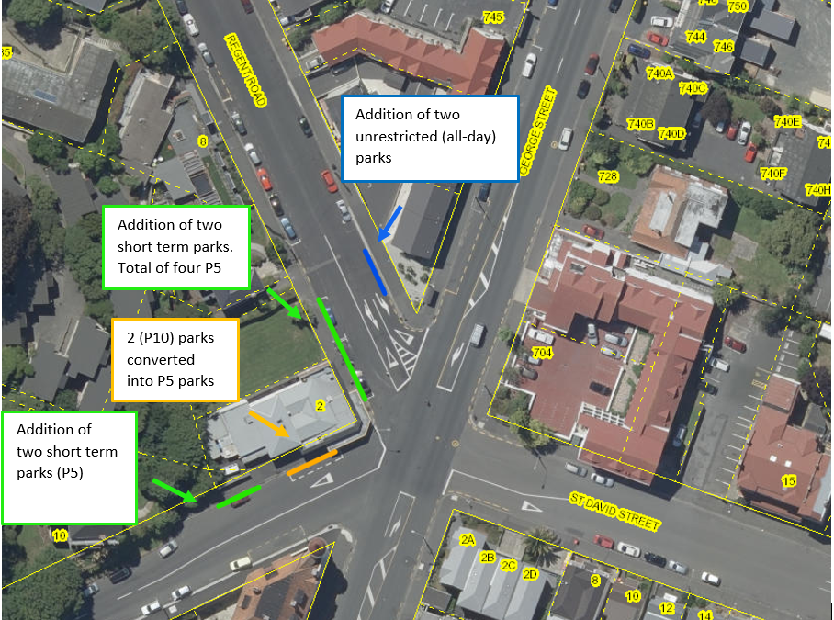

Furthermore, with the proposed improved crossings for pedestrians we believe two short term car parks should be installed on the left side, driving upwards on Park Street. These are identified in pink below;
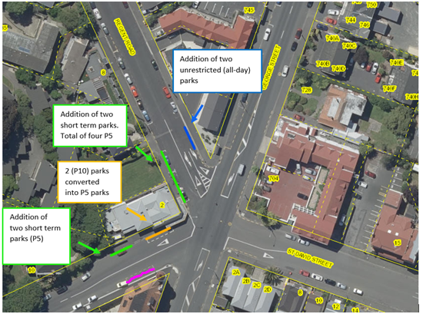
The pink line was historically park 10 car parking, before having a bus stop installed. That bus stop has since been decommissioned but replaced with all day carparking. By reinstalling the previously P10 carparks it will remove the need for any U-turns to utilize the short term car parking on the downward section of Park Street. This is also helped by easier crossing facilities allowing drivers to cross the road safer than they layout previously allowed.
St David Street – Two Way
We propose to keep St David Street two way. The street is a key arterial route to the Roslyn and Maori Hill suburbs. By removing the two-way nature, it will move motorists to one-of-two possible direct avenues from the one way identified in pink below.
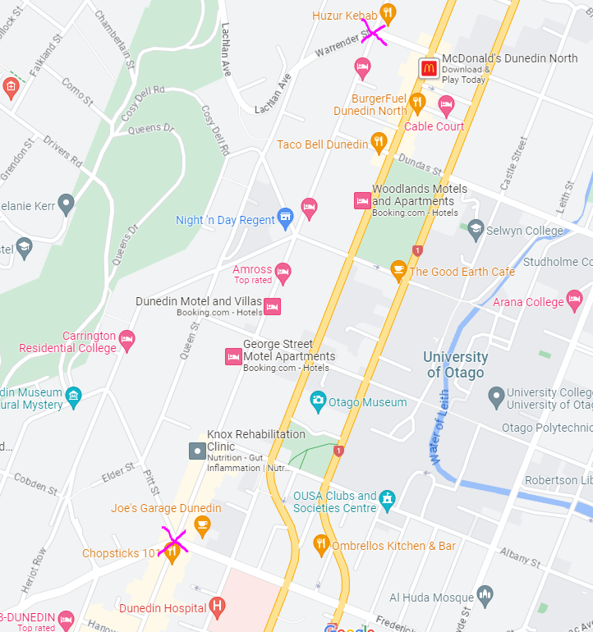
Both locations are less desirable to direct traffic to; one being next to the CBD the other being directly next to a primary school. To have cars using St David Street as the main arterial route between the one-way systems and hill-top suburbs removes congestion from these two areas. It should be encouraged to have vehicles to use this pathway verse redirecting them elsewhere.
Any customers attempting to shop at the store from the one way will need to turn either South or North of St David Street. This will increase traffic congestion for both the North and South parts of George Street instead of providing a direct accessway.
The current trial (to my knowledge) has provided no adverse effects by leaving St David two way, while the roundabout has slowed vehicles and created a clearer order of entry.
In summary, the changes I would recommend further to the current trial are;
- Improved pedestrian crossings
- Addition of two short term parks on Park St to prevent U-turns.
Every other component appears to be working effectively.

