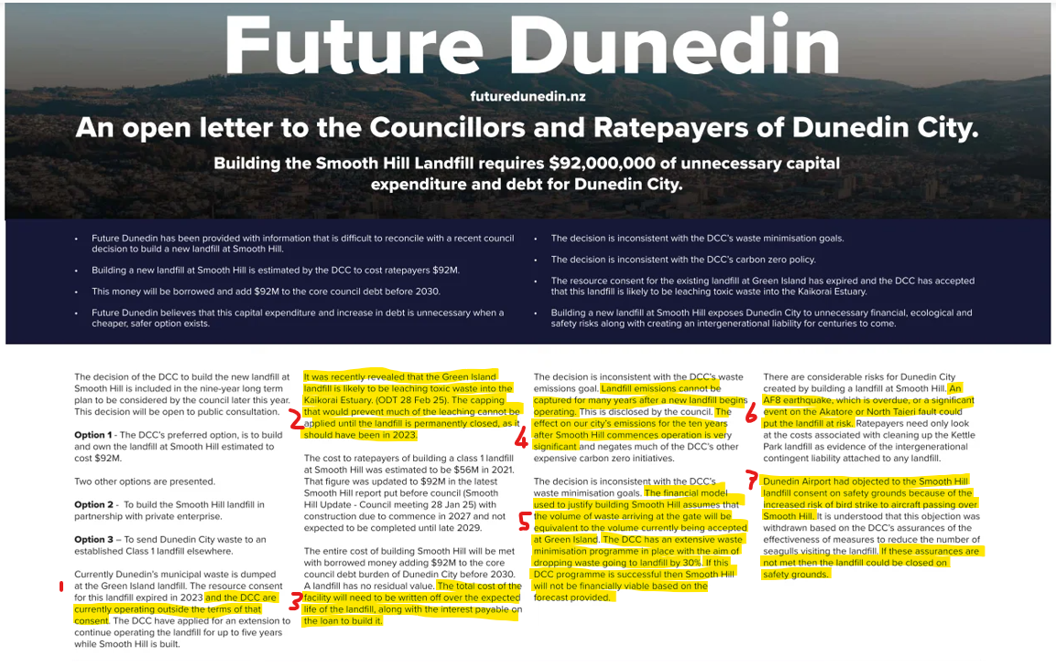
- As required by the Resource Management Act, the DCC continues to operate the Green Island landfill within the terms of the expired consents until a decision on replacement consents is received.
- Historical and ongoing environmental monitoring shows no discernible impact from the Green Island Landfill on stream or estuarine water quality or ecology. It is acknowledged that increasing the monitored parameters would improve the quality of the monitoring dataset. Capping can only be applied to completed sections of landfill. It is the leachate collection system that prevents leachate from escaping into the wider environment, and the Green Island landfill leachate collection system discharges directly into the main sewer to the Green Island Wastewater Treatment Plant.
- This comment ignores landfill revenue received by the DCC, which can be used to finance ongoing operational and interest costs etc.
- A landfill gas collection system can begin to be established after the initial 2 or 3 years of operation of a municipal landfill. The emissions from Smooth Hill will be significantly lower in comparison to Green Island due to the removal of most of the food and garden waste from the waste stream, further assisted by the removal of some construction and demolition wastes (e.g., timber) from the waste stream.
- The financial model used in the Smooth Hill Business Case included modelling for low waste volumes. Low waste volumes also result in a significant increase in the usable life of the landfill.
- The Smooth Hill landfill will be built to modern standards, including consideration of significant seismic events, which will reduce the risks as much as possible; however, the effects of an AF8 event on the transport network are likely to be significant, making transport of waste over 200 km to an alternative landfill extremely difficult.
- The conditions for Smooth Hill include measures to prevent a bird population from establishing on the site, and DCC and Dunedin Airport are working collaboratively on ensuring that these measures will be effective.
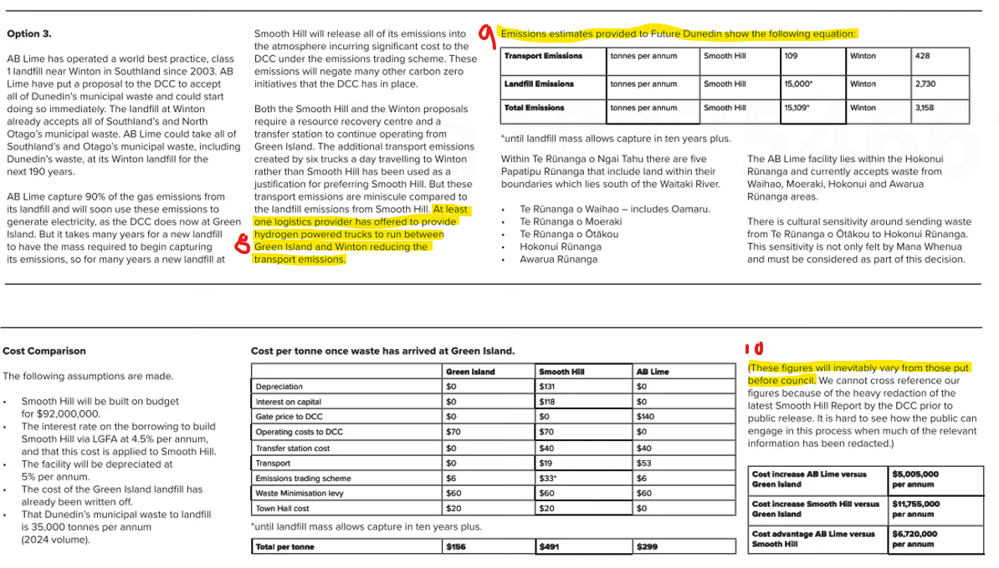

- Council is not aware of any such offer, or of a logistics provider with an available hydrogen powered truck fleet.
- Estimates cannot be verified, but these figures are based on 10 years (refer comment 4 above) and appear to ignore the removal of most food and garden waste (plus timber wastes) from the waste stream.
- Agreed, these figures are incorrect and differ significantly from those provided to Council during preparation of the Smooth Hill business case.

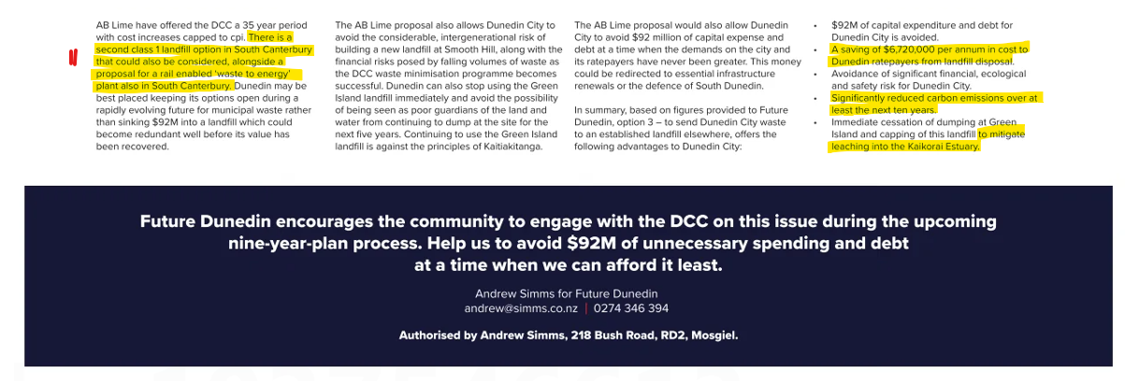

- Council is not aware of any formal 35 year offer from AB Lime. Currently the only class 1 landfill in South Canterbury is the Timaru District Council’s Redruth landfill, which does not accept large quantities of waste from outside of the Timaru district. This statement may be a reference to the new Taiko landfill in South Canterbury which is currently a class 2 facility (i.e., construction and demolition waste) and is unable to accept domestic household waste. Canterbury Environmental Solutions | Reshaping Civil & Construction Waste

