Wednesday May 1st 2024

Re: Aurora Energy Sale Proposal

Kia ora tātou

Thankyou for the opportunity to submit on the proposal to sell Aurora Energy. As the most significant sell down of city assets since the late 1990s, and the biggest voluntary sell down in living memory, it is worthy of mature and robust public debate.

Unfortunately, the Statement of Proposal (SOP) issued to support the consultation doesn’t give us enough information to enable that.

There may well be a case to be made to privatise Aurora, but the SOP does not make it.

In support of council’s preference for asset sales, the expected market value for Aurora is described as including a premium over and above its capital value. That should be a sign to council that it is worth retaining as a long term asset.

We are told it is unlikely to return dividends in the short term, and will be less lucrative for council than a managed fund in the short to medium term, but there’s no discussion of the longer term.

Council has an obligation to make decisions in the best long term interests of the city.

The alternative to selling Aurora is keeping it. Disadvantages listed in the SOP include that it will need to borrow more money, and as a result DCHL’s group debt will increase. This is presented as inherently bad without any discussion of why such borrowing would be imprudent, or what the implications of it would be, beyond a presumably political desire to reduce debt levels.

It is mentioned more than once that the price regulation of lines companies means that Otago residents will be protected from any unreasonably high user charges as a result of privatisation.

There are two questions that arise from this:

1. What confidence does council have, particularly under our current government, that the regulatory environment won’t change?

Given the staggering infrastructure deficit the country is in; the political appetite for private delivery of public infrastructure; and the bullish nature of our deregulatory environment, could you rule out a loosening of these price controls in exchange for private infrastructure investment?

2. Does council not consider there to be any other strategic reasons the city might want to influence the direction of Aurora Energy?

The capacity of our electricity infrastructure, and the investment decisions that support that, will be critical to the decarbonisation of our towns and cities. In the absence of clear national direction, which any private owner of Aurora would have to give effect to, maintaining ownership would allow the opportunity to assert the city’s strategic aspirations.

Given the uncertainty of the government’s legislative programme, the Dunedin City Council took the option to defer approval of a Long Term Plan (LTP) until June 2025.

This is important not just in terms of considering council expenditure, which will influence thinking about potential revenue sources. The LTP is also where strategic documents such as the Significance & Engagement Policy are reviewed, considered and approved.

Likewise, council are being asked to take a decision on the ownership of Aurora Energy before agreeing on a framework for dealing with, and protecting, the realised capital it would generate.

Council could change the threshold for votes on divestment, a la the Waipori Fund in Standing Orders, but they haven’t.

In essence we’re being asked whether or not to support the sale, and then to just ‘trust us’ when it comes to the next steps.

What happens next should be material to any individual’s appetite for privatisation. It is also unclear from the SOP what the urgency is with regards to a decision on the sale of Aurora Energy.

Recommendation 1:

That Council, based on the information provided in the Statement of Proposal:

a. Not proceed with the sale of Aurora Energy; or
b. Reconsult on the sale of Aurora Energy following a review of the Significance & Engagement Policy, and the adoption of a policy framework to manage any sale proceeds; and
c. Commit to approving such a policy framework by way of a Special Consultative Procedure.

If council decides to reject the recommendations above, and proceed with the sale as part of this consultation process, it is imperative that there be public input into the design of the proposed investment fund.

Recommendation 2:

That Council, in the event of establishing any new investment fund, commit to approving its structure by way of a Special Consultative Procedure.

Aside from the ill defined debt issue above, the main imperative for this seems to be to increase non-rateable revenue on an annual basis.

Through a combination of a lack of political will and relatively few revenue sources – compounded by the current inflationary environment – it is becoming more expensive to deliver the services our community expects and deserves.

This is not a problem unique to Dunedin. Up and down the motu we’re seeing significant increases in rates to try and bridge the gap. The Dunedin City Council isn’t the only council having a debate about how best to manage its investment portfolio.

Councils are discussing whether to sell assets and put them at the mercy of global markets, and by extension put their capacity to fund civic services at the mercy of the same.

It is a short term solution to a much more critical, and structural, problem around local government funding and financing.

Halting this process, or at the very least deferring a decision, would allow council the opportunity to work with the wider local government sector on addressing the root cause instead.

If council do choose to proceed with their preferred option, I think we should be looking at more relevant ways of reinvesting the proceeds than just an offset for general rates, or paying off debt.

Given the influence in the network that would be surrendered, and the genesis of any investment fund, it would be appropriate to spend the annual dispersement on related fields. Supporting energy efficiency initiatives would be one such option, but a more timely one would be supporting the city’s climate change response.

Recommendation 3:

That in the event of council establishing a special investment fund being, from the proceeds of the sale of Aurora Energy, the annual dispersements from it be applied to energy efficiency and/or decarbonisation initiatives.

Thankyou once again for the opportunity to submit on this.

I would like to speak to my submission in due course.

Kā mihi
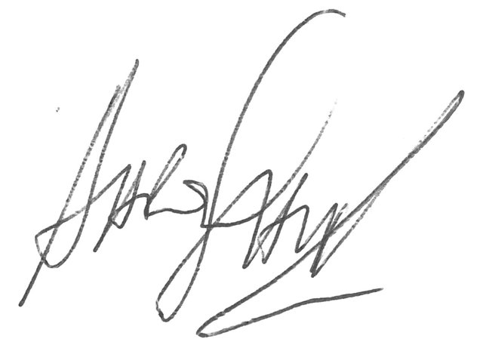

Aaron Hawkins

