9 year plan Submission
31st March 2025
Hoani Langsbury
Royal Albatross Centre / Local Resident

Te Awa Otakou / Peninsula Connection
Three sections yet to be completed, in order of priority that they need to be funded;
- Ellison Road to Otakou Fisheries
Most dangerous section of road in the project. Was originally of the highest priority.
Have spoken with the Tourist operators that use this road, and they all agree it is the most unsafe section of the road, both before the start of the creation of the shared pathway and road improvements.
Specifically spoke with the driver trainer for Ritchies and he informed me that there is no safe way of traverse this section without the buses having to cross the centre line on blind corners.
I encounter this daily as a local resident and have at least once had to stop on a corner after a bus wedged itself against my vehicle.
The only way for the safety concerns to be addressed is for the safety improvement to be complete as a high priority for the ORC.
Have note twice in the last 12 months where the road has been under water, during a spring high tide.
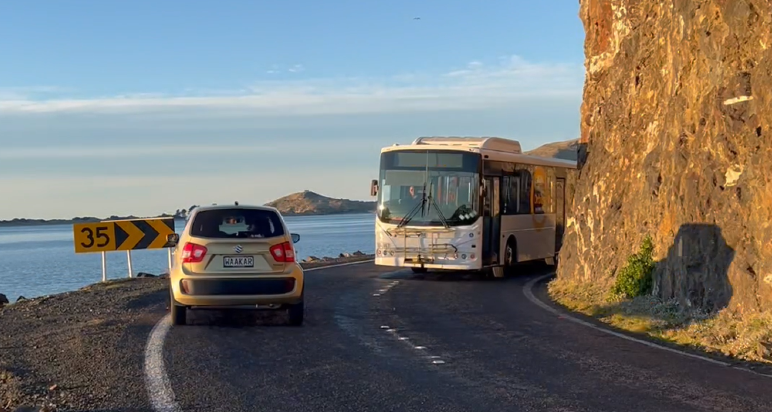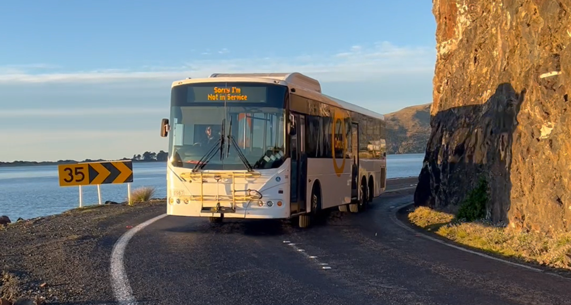

- Portobello School Cutting
Shared pathway needs to be established to link Portobello to the bus turnaround at Portobello bay. Support the submission from Portobello School.
- Dessert Road Section
From Harwood turnoff to Ellison Road.
The design work has already been completed, and consultation and agreements were completed with affected landowners etc. These may need to be revisited, by were effectively completed.
Maintenance and stormwater.
The shared pathways need to be maintained as they are the gateway to the Otago Peninsula, the focus of “Wild Dunedin”. There is a significant focus on the ecology, sustainability and promotion of the Otago Peninsula during the annual Wild Dunedin Festival. This gateway lacks regular love and attention from the contractors that are responsible for the maintenance of Portobello and Harington Point Road.
During any rain event we see plumes of sediment from most of the culverts along the road way entering the harbour. It is not only on the Peninsula side of the harbour that we see this, but from the entire catchment. With much of this stormwater originating from Roading & Reserves around the Harbour.
The minimum expectation of the DCC as a good neighbour to the harbour would be to reduce the impact of rain events on the sensitive receiving environment of the harbour.

Pest Species.
DCC Reserves, transport corridors and the shared pathways are havens for both pest plant and pest animal species. At a minimum the DCC needs to ensure they retain sufficient funding of the 9 years to meet their responsibility to manage pest species on DCC land.
The other and just as important obligation is to act as a good neighbour to properties that are working toward suppression or eradication of pest species and insure that fund and act as a good neighbour.

Water and Sewerage.
The Otago Peninsula road corridor contains the infrastructure that reticulates both water and sewerage from residents and businesses on the Otago Peninsula. Reticulation needs to be extended beyond Portobello, to Harwood, Otakou and Pukekura. The importance of this will become more evident as sea-level rise impacts on the ability of long-drops, septic tanks etc to be able to effectively treat effluent into the future.
The opportunity to place the pipes in the ground during roading maintenance and construction needs to be given consideration where it does not affect the timeliness of these major roading infrastructure projects.

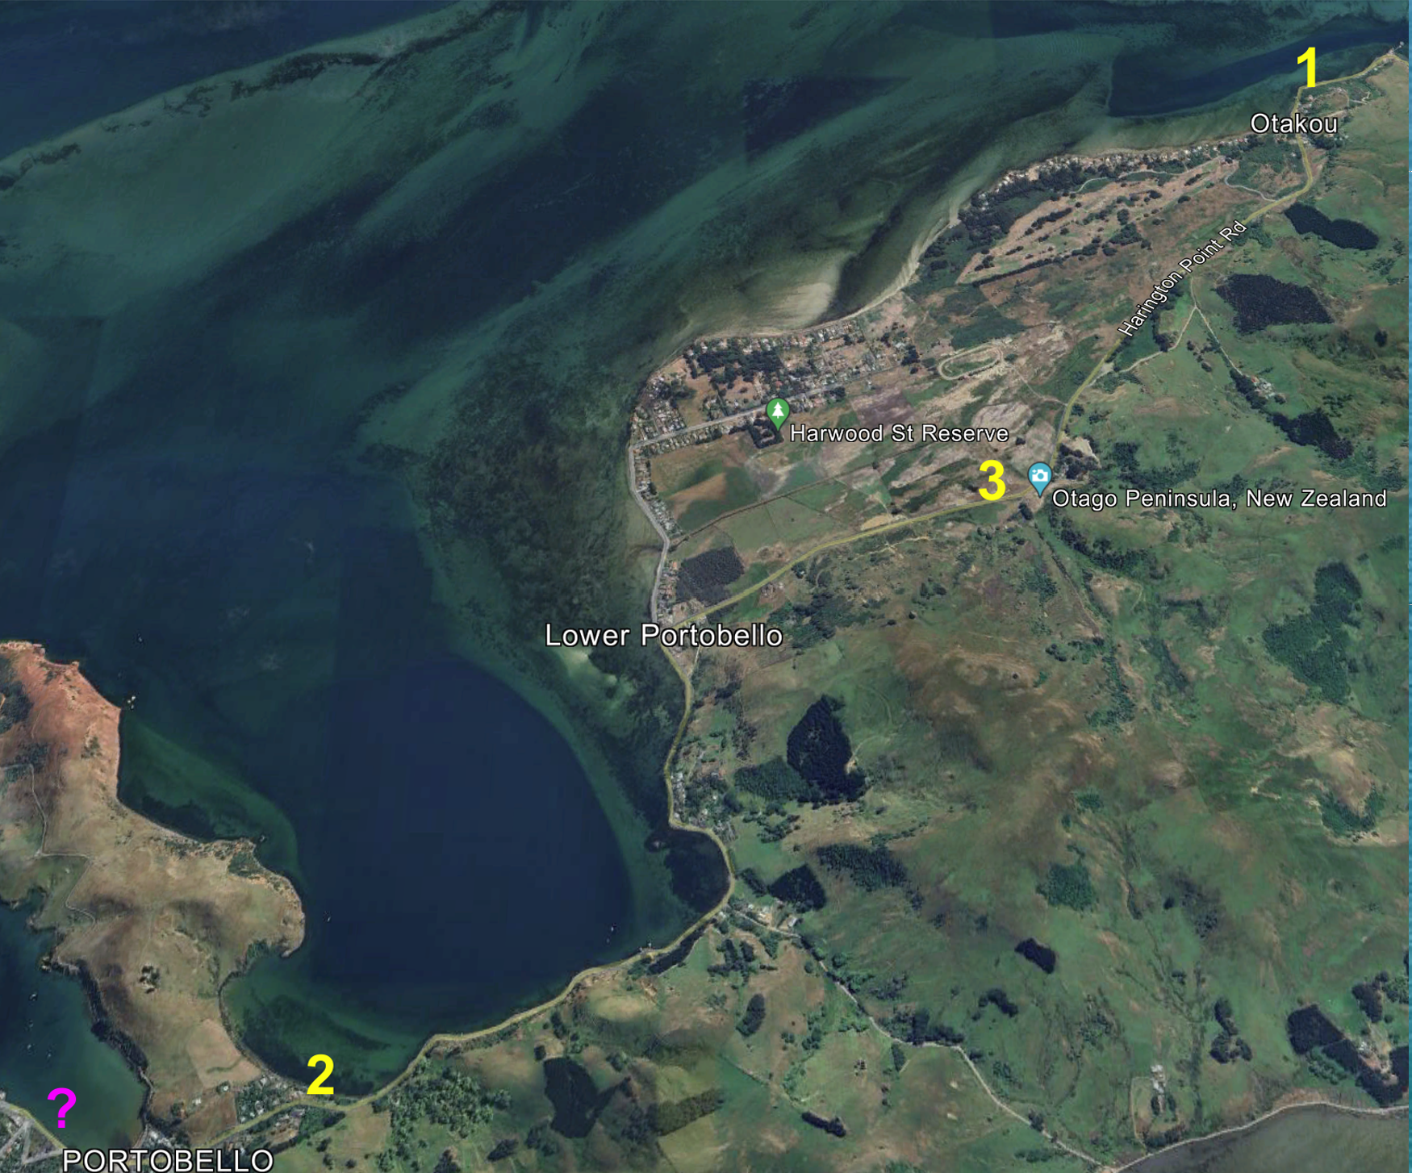

Thank you for your consideration of my submission.

I wish to be heard!



Hoani Langsbury
0274306025
manager@albatross.org.nz

