For the benefit of the city it is important that the development contributions document that has been tabled is reviewed and amended where required.
“Fair, equitable and proportionate”
These are words from the Draft Development Contributions document.
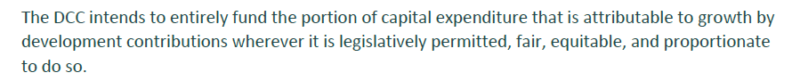
Please note, not all change can be attributed to growth, but let us look into those words. How narrow or how broad is that focus? Is this a holistic view on development or is this a statement on the council’s components of the development process at a time of financial strain. I believe it is the latter and in doing so these contributions are not a proportionate approach to contributing to the development costs of growth. The total development costs of growth go beyond council processes. We have tax brackets in New Zealand for very good reasons, yet we do not have local authorities taking that approach to financial contributions for those who have more or lesser resources.
Is it fair for someone to look into the opportunities that have been created by the Variation 2 document to the 2GP where infill development to meet a housing demand was encouraged to now see those same intended opportunities diminish so quickly? This document discourages householders from alleviating the housing issues through incremental infill subdivision. Proportionate to the scale of the development, infill subdivision pay more per new allotment than multi-lot developments. There are economies of scale to consider due to other associated costs.
A specific area of interest is social housing. Very few social housing developments are large multi-lot subdivisions. Many, such as the Kāinga Ora projects we have worked on in recent years are 3-5 house projects that would be marginalised through the application of the proposed policy. By applying the development contributions on per lot or per building basis, this affects all new developments that add to the city’s housing stocks. Do we want to discourage smaller social or infill housing when greenfields multi-lot subdivisions and large multi-unit developments get the economies of scale to still return better profit margins? To put that another way, if you want the rich to get richer and other’s opportunities to wane, keep going on your current course.
Is there a consideration for environmental factors? I cannot see this mentioned anywhere in the draft document. The 2019 NIWA Climate Change Projections for the Otago Region document suggests that while the number of days that qualify as ‘high rain days’ will only increase by around 1 day a year by 2090 in eastern Otago, what will change is the rainfall intensity. The changing weather patterns we have noticed over the past two decades suggest that these changes may have commenced and the frequency of 1 in 100 year rainfall events is increasing. Surely, this is having an impact on stormwater infrastructure demands and needs as well. If this is an exclusion and is already considered in the rates projections, then I accept that. If it is not considered that stormwater flows are changing in the existing Citywide area then these considerations should not be paid for under future expenditure by developers alone.
Another way to look at the proportionate aspect is what proportion of the total subdivision costs are development contributions making. While this will vary with site specific subdivision and building costs, the percentage of the total development cost that can be attributed to development contributions is growing at a rate that is disproportionate to any other part of the process by some margin and is reducing the opportunities for others to even adjust prices to levels around that of inflation.
The draft document’s statement of Section 101(3)(b) is unacceptable. There is no further justification for the statement shown below.
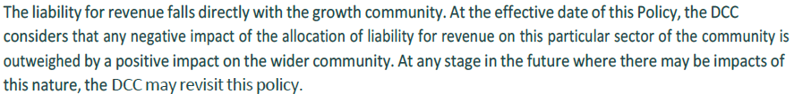
What metrics went into the assessment of negative impact and how is that assessed against the positive impact on the wider community? This is an empty and convenient statement without support from reasoning for its basis. Further to that point, it is small subdividers, (the families, couples and smaller operators) who tend to undertake 2-lot to 5-lot subdivisions who will be most felt by these changes. It is also the smaller contractors, smaller survey firms and smaller associated businesses that tend to assist the smaller subdivisions that will also suffer. Job losses are a real possibility, whereas larger businesses and developers have greater resources to withstand the reduction in work and could still benefit from larger developers who, with economies of scale, can withstand such changes.
The harsh reality of different processes and infrastructure standards historically within what is now Dunedin City will impact significantly on some smaller communities as a result of this development contributions policy. It will limit the property options and the potential saleability of some existing properties compared with the potential they had prior to subdivision costs reaching the proposed levels through development contributions. Middlemarch and Waikouaiti are clear cases here. Neither, prior to being amalgamated into the current Dunedin City, required the services that much of urban Dunedin has enjoyed. Should those everyday services available to Dunedinites not be provided to those communities by the council directly?
Further to my previous points, I am left questioning how these figures and the relative rises differ so greatly from the previous shifts in development contributions. The document is poor, in that while it gives background to its statutory rights to assess development contributions, it does not state why the increase is so dramatic in the context of previous rises in contribution levels which in themselves were surprising. The council must also consider if some processes for development are becoming cost prohibitive and hence some of the intent of variation 2 to resolve housing pressures may not eventuate. This would not only accentuate the need for housing but display a waste of council funds and work hours developing the plan and it’s variation. There has also not been an open record corresponded to those that work in property of where the development contributions have gone so far and whether they have been fully used within the 10 year period.

The statement below requires more explanation. Professional judgement is an easy statement to make but who’s judgement was that and what perspective or role on the development process do they undertake? I am not aware of any surveyors being part of the assessment. Surveyors frequently cost roading, drainage and other associated development costs and are professionals who are part of the process from the start to the finish. I do not doubt that other professionals have useful contributions to make also.
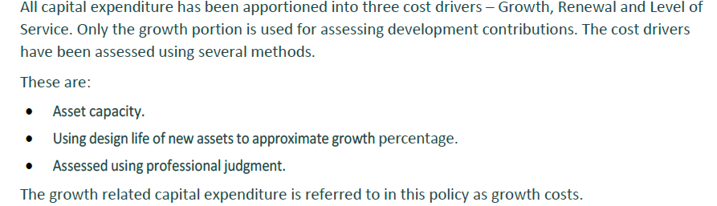
Table 3: Equivalent household unit determinations are sound mathematically but they again do not consider economies of scale or the people and resources of those people who are most likely to undertake small scale subdivision or building.
In addition, the review period below is too short. For a subdivision process that can now take 12 months or more to undertake and also requires months of planning, an annual adjustment does not deliver confidence to people entering into the process. This is particularly in the case of people commencing the projects in March to June who may not have secured a resource consent to subdivide before the change/reassessment of costs in July of each year. Budgeting and securing finance can frequently take time that would be marginalised here.
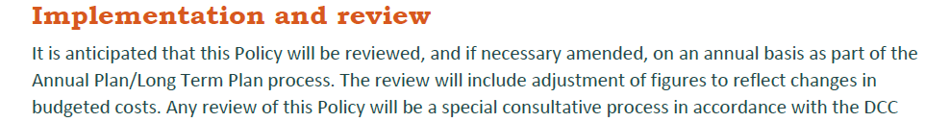
The period for the further assessment of development contributions is too short given the increased compliance costs and the length of time required from consent to the issue of a s.224c certificate for a subdivision that requires engineering works. Does this also apply to existing development contributions that were levied prior to this proposed draft document being released?
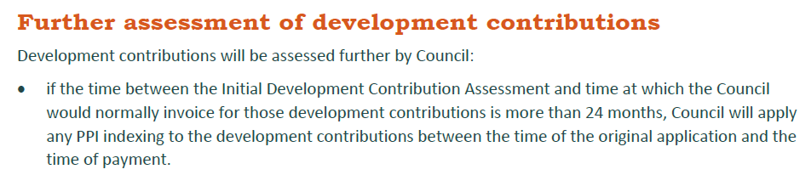

The terms ‘areas of benefit’ and ‘growth community’ are euphemisms and need to be more direct and not so patronising. The land use categories are more like GIS mapped names and do not consider economies of scale and the disparity of opportunity that exist within our communities. A new approach to social considerations and associated costs needs to be explored. The landuse categories are a well-intended method to group areas of need. They do, however, appear more akin to zones on this occasion than the intertwined communities we have in reality, where project scale and availability of resources for site specific projects are the main determinants of cost. A system that is tiered that relates to scale and profitability and the ability to cover holding costs is what householders need to assess development opportunities. This can be coordinated with the DCC’s very real financial considerations but in a different format to what the draft document displays.
If a problem is identified, and I believe the current proposal has numerous problems, I believe a proposal to resolve the matter or a conversation to progress the matter needs to be commenced. The alternative needs to also consider the financial need of the DCC but also needs to be fair, equitable and proportionate. As I have already intimated, I believe we need to look at the taxation system for a model and have thresholds for different sized subdivision to be generally proportionate with total development costs. I also believe that 6 units and 12 units (consistent with the threshold for transportation) are good starting points to assess small or middling developments. I propose tiers that could be, subject to further discussion, 1-6 lots/houses, 7-12 lots/houses, 13-30 lots/houses and 30+ lots/houses. Each tier would have an increased contribution associated with it than the tier lower than it. Restrictions would be put on people undertaking multiple 6 lot subdivisions who are attempting to avoid larger contribution. I propose that a parent title could not be further subdivided at the lower rate within a given time period. This proposal needs discussion with the DCC and should not be rushed to meet an arbitrary date for the 9 year plan.

In summary, I believe the draft development contributions document is deficient in a number of areas and is more a mapped financial proposal than a document that considers both the financial and infrastructure needs of the city along with socially-minded, proportionate and fair financial systems. It is narrow in its assessment as it does not consider the legally determined process for subdivisions to occur that include but also go beyond council processes and costs. My concerns are largely for the people with smaller holdings that have subdivision potential and for those undertaking social housing projects who have marginal to negative profit margins but still have to sustain and carry the costs throughout the process. These costs include the proposed development contributions that may, unfortunately render social housing and philanthropic projects unlikely to proceed with such harsh financial costs. The tiered proposal considers what the draft document’s fundamentally mathematical approach does not consider and that is the economies of scale. Some other associated development costs are fixed or relatively similar regardless of the size of the subdivision and some larger developments have savings with the economies of scale. As stated, I propose tiers that could be, subject to further discussion, 1-6 lots/houses, 6-12 lots/houses, 13-30 lots/houses and 30+ lots/houses. Restrictions would be put on people undertaking multiple 6 lot subdivisions. A working group of surveyors would be appropriate to discuss this further with the DCC.

