30th April 2025

We thank you for the opportunity to submit

Football South is the provider of football throughout the Southern region from Geraldine in the north to Bluff in the south and covers all of Central Otago and the areas in between. We have 8500 winter members and over 9000 futsal participants

We are currently the largest user of fields in Dunedin with 49 full size fields, 45 junior fields and 16 changing facilities

We do not support the proposed change from 4% rebate on costs for fields to the proposed 5% .

This represents a 20% increase on the current policy

This represents significant increase for those wishing to play the game and thus becomes potentially inaccessible.

Eg
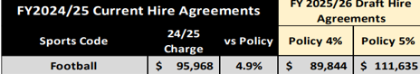

This represents a significant increase of over $22K for just Dunedin players which would mean an increase of up to $6 per player.

Currently the DCC costs account for 44% of the fess we collect from Dunedin players.

Some of us have already been overcharged, based on the current policy settings of 4% as we are at 4.9% while others are significantly below the 4%

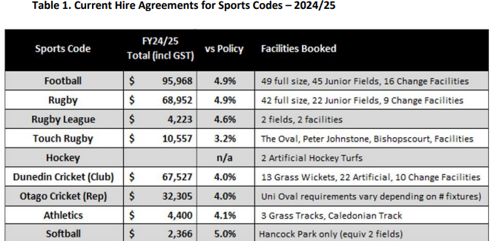

Our first recommendation is that all codes should pay the 4% as a starting point
Currently the vast majority of those who play the game in dunedin are Rate payers so they are effectively being charged again. This is not the case for other public facilities and amenities throughout the city

We are also interested in the current charges based upon the 4% rebate fee: we are told

“For the 25/26 proposed fees are based off a cost per field of $19,641
Cost per facility (change rooms) $20,706
Cost per turf $71,909
Costs of lights per field $4,614

These costs were averaged across all our facilities from the total annual seasonal costs.”

So can councillors confirm that the fields that are hired from council, but the electricity for those fields are paid for by the club do not incur that “averaged cost” eg Culling Park/Memorial Park we are charged $1180.40 and for half the year cricket use it and the club pays the power???

I'm also interested in the costing etc of non lit no changing rooms grounds if the costs of maintenance lining is $19641 (it would be great for openness to understand what all that costs are). A 4% would mean a charge of $785.64. However we only use that are for half a year $392.82. Kensington Oval 3 $1180.40 with no lights and cricket usage over summer.

We wonder how this decision can be in when it is in contrast to the Parks and Recreation Strategy 2017-2027

“At the core of this strategy is a vision to encourage ‘Dunedin’s communities to be more active, more often, spending more time enjoying a connected and valued network of facilities, parks and open spaces.’

There ore other significant councils that we not included as examples in your previous papers that charge no fees. For example Auckland and Christchurch

If there are increased costs then more than likely we will need to reduce the number of fields we have allocated (as we have had to do in 2025). This increase the use on current grounds meaning they will need more maintenance required to keep them up to standards and at the end of the season considerable remediation work required which could effect other codes. Equally, its meaning that people will have to travel further , more than often not in cars thus again this decision does not support the work on reducing carbon for the city and the councils strategic environmental sustainability policies

On the inclusion for charging for lights. I would recommend that before a decision is made that implementation costs are investigated.

As the proposal would be aimed at shared facilities the council will need to develop and implement a user charging process, This will include coding/pin access systems for clubs and teams to put in so that costs can be associated to that club and team. Thus the council needs to be responsible for charging clubs directly for this cost. It is our opinion you cannot implement a charging change and then just pass it onto the federation to administer. We do not have the capability of time and resource to be able to cope with the accounting demands required to do this. Equally it will be essential that lights for each filed can be activated separately and not be partnered up with other lights. The lights usage will need to be independent of the field booking process, thus codes needed for clubs and teams

Please get in touch if you have any questions at all.

Dougal McGowan
Southern Football
finance@southernfootball.co.nz

